11.Write a program to print the following pattern.

1

12

123

1234

12345

**PROGRAM:**

n = 5

for i in range(1, n + 1):

print(" " * (n - i), end="")

for j in range(1, i + 1):

print(j, end="")

print()

**OUTPUT:**

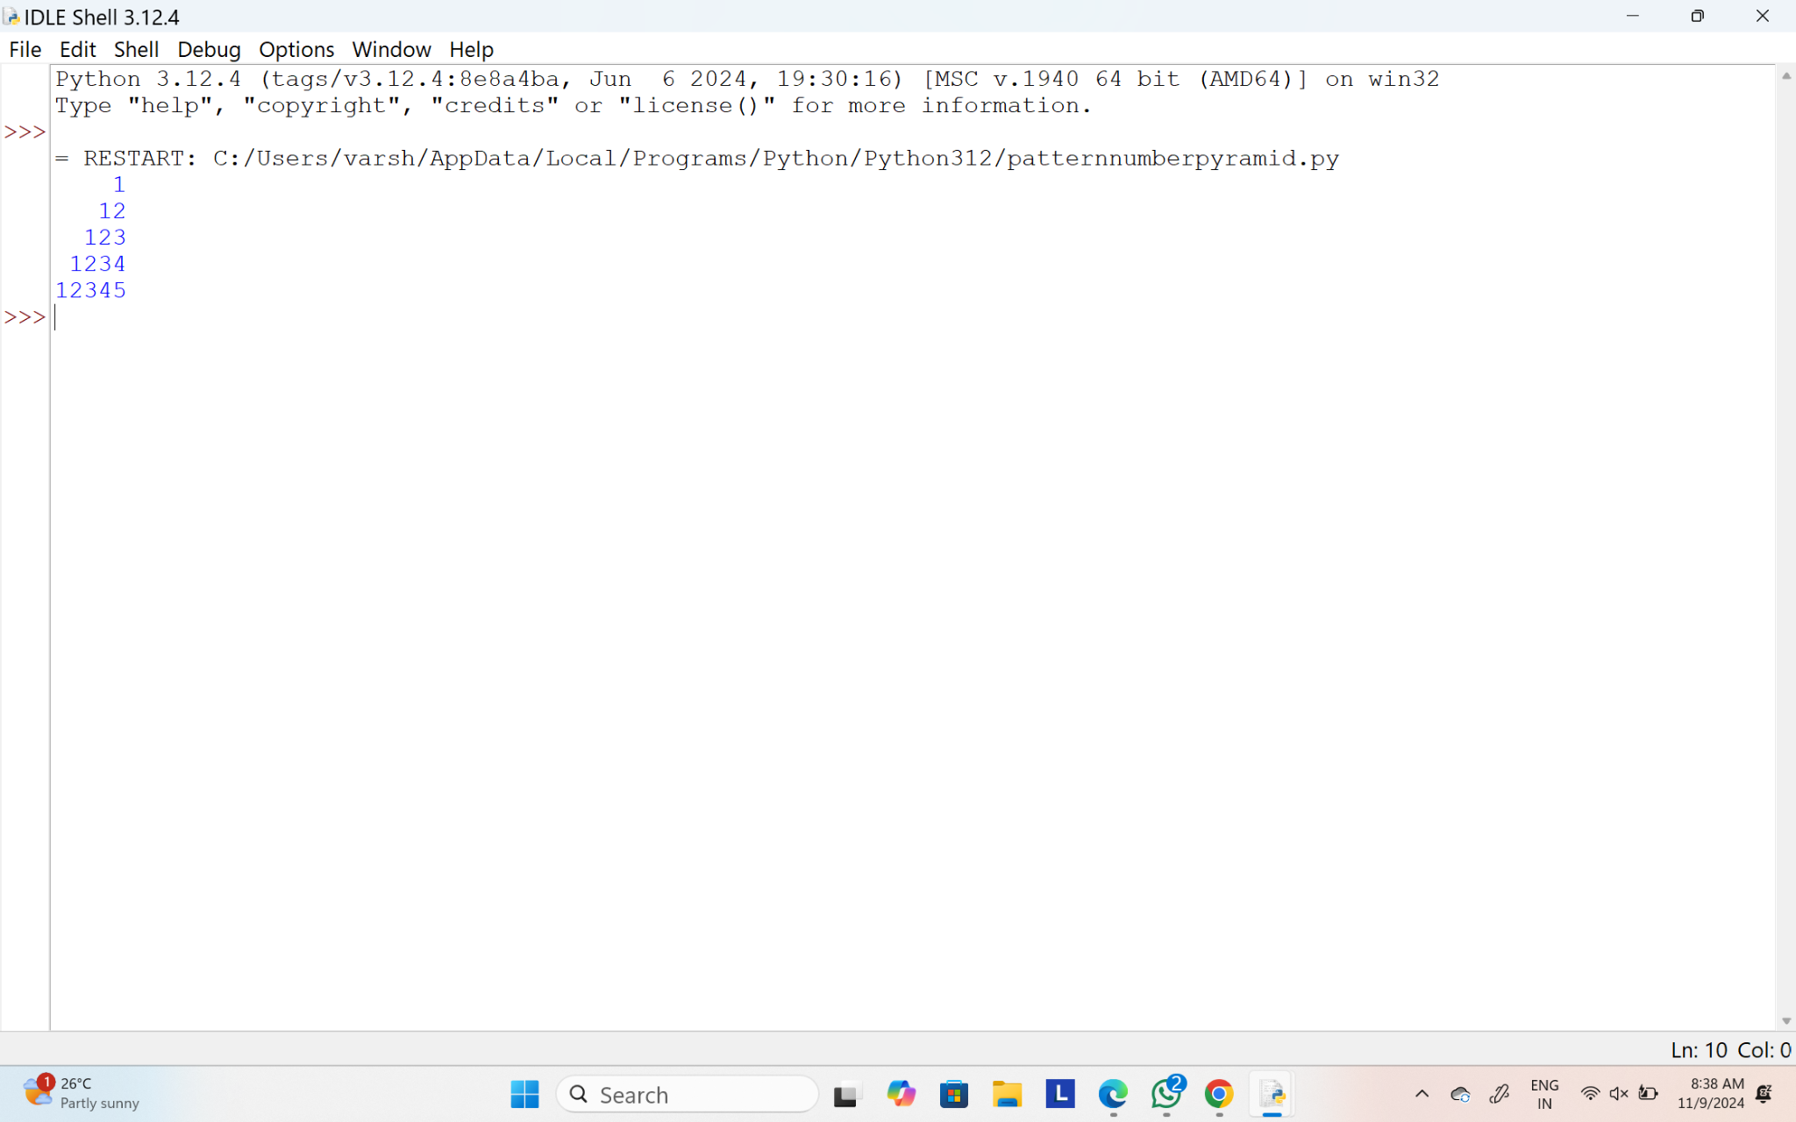

12.Write a program to find the number of student users in the college, get the total users, staff users details from the client. Note for every 3 staff user there is one Non teaching staff user assigned by default.

Sample Input:

Total Users: 856

Staff Users: 126

Sample Output:

Student Users: 688

Test Cases:

1.Total User: 0

2.Total User: -143

3.Total User: 1026, Staff User: 1026

4.Total User: 450, Staff User: 540

5.Total User: 600, Staff User: 450

**PROGRAM:**

def calculate_student_users(total_users, staff_users):

non_teaching_staff = staff_users // 3

student_users = total_users - (staff_users + non_teaching_staff)

return student_users

total_users = int(input("Enter the Total Users: "))

staff_users = int(input("Enter the Staff Users: "))

student_users = calculate_student_users(total_users, staff_users)

print(f"Student Users: {student_users}")

**OUTPUT:**

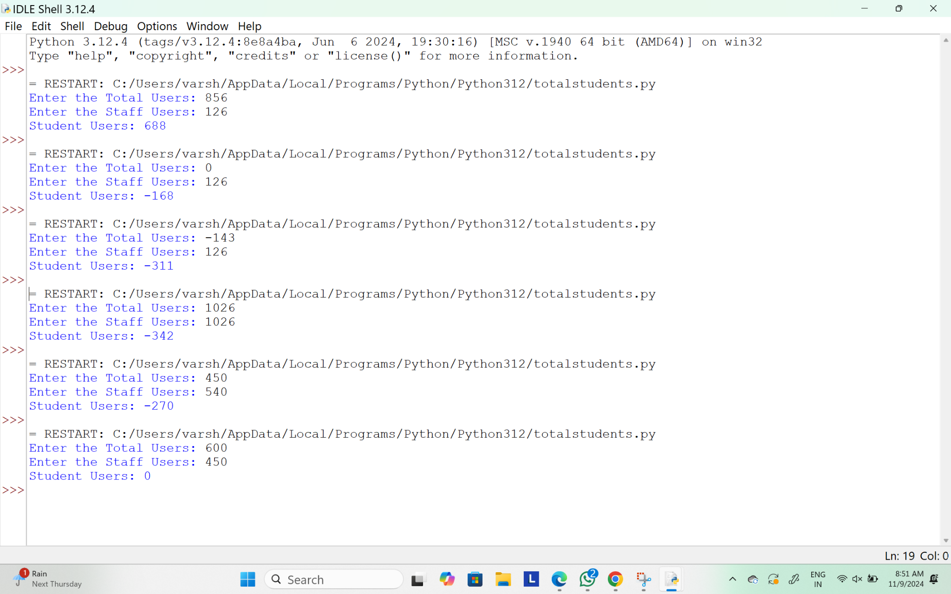

13.Write a program to convert Decimal number equivalent to Binary number and octal numbers?

Sample Input:

Decimal Number: 15

Sample Output:

Binary Number = 1111

Octal = 17

Test cases:

1. 111
2. 15.2
3. 0
4. B12
5. 1A.2

**PROGRAM:**

def convert_decimal(decimal_number):

binary_number = bin(decimal_number)[2:]

octal_number = oct(decimal_number)[2:]

return binary_number, octal_number

decimal_number = int(input("Decimal Number: "))

binary_number, octal_number = convert_decimal(decimal_number)

print(f"Binary Number = {binary_number}")

print(f"Octal = {octal_number}")

**OUTPUT:**

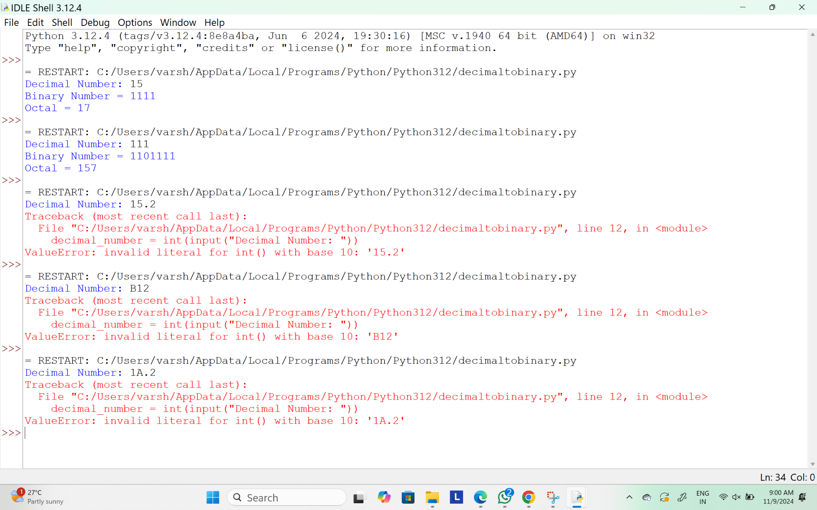

14.Write a program to print the below pattern?

|  |  |  |  | 1 |  |  |  |  |
| --- | --- | --- | --- | --- | --- | --- | --- | --- |
|  |  |  | 1 |  | 1 |  |  |  |
|  |  | 1 |  | 2 |  | 1 |  |  |
|  | 1 |  | 3 |  | 3 |  | 1 |  |
| 1 |  | 4 |  | 6 |  | 4 |  | 1 |

**PROGRAM:**

def print_pascals_triangle(n):

triangle = []

for i in range(n):

row = [1] * (i + 1)

for j in range(1, i):

row[j] = triangle[i - 1][j - 1] + triangle[i - 1][j]

triangle.append(row)

for row in triangle:

print(" ".join(map(str, row)).center(n * 2))

print_pascals_triangle(5)

**OUTPUT:**

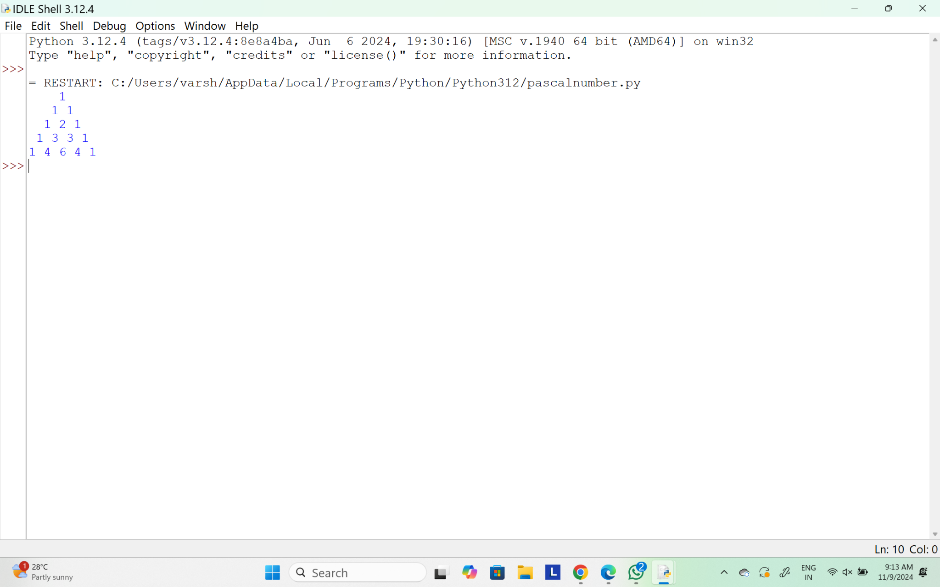

15.In an organization they decide to give bonus to all the employees on New Year. A 5% bonus on salary is given to the grade A workers and 10% bonus on salary to the grade B workers. Write a program to enter the salary and grade of the employee. If the salary of the employee is less than $10,000 then the employee gets an extra 2% bonus on salary Calculate the bonus that has to be given to the employee and print the salary that the employee will get.

Sample Input & Output:

Enter the grade of the employee: B

Enter the employee salary: 50000

Salary=50000

Bonus=5000.0

Total to be paid:55000.0

**Test cases:**

1. Enter the grade of the employee: A

Enter the employee salary: 8000

1. Enter the grade of the employee: C

Enter the employee salary: 60000

1. Enter the grade of the employee: B

Enter the employee salary: 0

1. Enter the grade of the employee: 38000

Enter the employee salary: A

1. Enter the grade of the employee: B

Enter the employee salary: -8000

**PROGRAM:**

def calculate_bonus():

grade = input("Enter the grade of the employee: ").strip()

salary = float(input("Enter the employee salary: "))

bonus = 0.0

if grade == 'A':

bonus = salary * 0.05 # 5% bonus for grade A

elif grade == 'B':

bonus = salary * 0.10 # 10% bonus for grade B

else:

print("Invalid grade entered.")

return

if salary < 10000:

bonus += salary * 0.02

total_salary = salary + bonus

print(f"Salary = {salary}")

print(f"Bonus = {bonus}")

print(f"Total to be paid: {total_salary}")

calculate_bonus()

**OUTPUT:**

